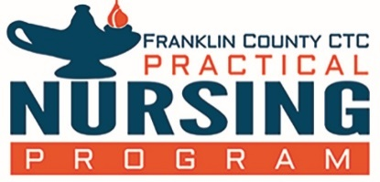
FRANKLIN COUNTY CAREER & TECHNOLOGY CENTER
PRACTICAL NURSING PROGRAM
FCCTC-PNP Program Outcomes and Success Measures

Program Outcome 1: NCLEX-PN performance pass rates will be at least 80% for all first-time candidates during the same 12-month period (Oct 1 – Sept 30). Source: Pennsylvania State Board of Nursing www.dos.pa.gov

Year | National Average | FCCTC-PNP
2018-2019 | 85.76% | 93.33%
2017-2018 | 85.38% | 100.00%
2016-2017 | 83.65% | 90.00%

Program Outcome 2: Program completion rate will be at or above 70% (% of students completing program that started in cohort of year listed, and completed within 150% of the program length)

Year | % of Students
2018 | 63.80%
2017 | 63.60%
2016 | 73.90%

Program Outcome 3: 90% of graduates seeking employment will obtain employment within one (1) year of graduation.

Year | % Employed in one (1) Year
2018-2019 | 100%
2017-2018 | 100%
2016-2017 | 100 %

March 1, 2020

